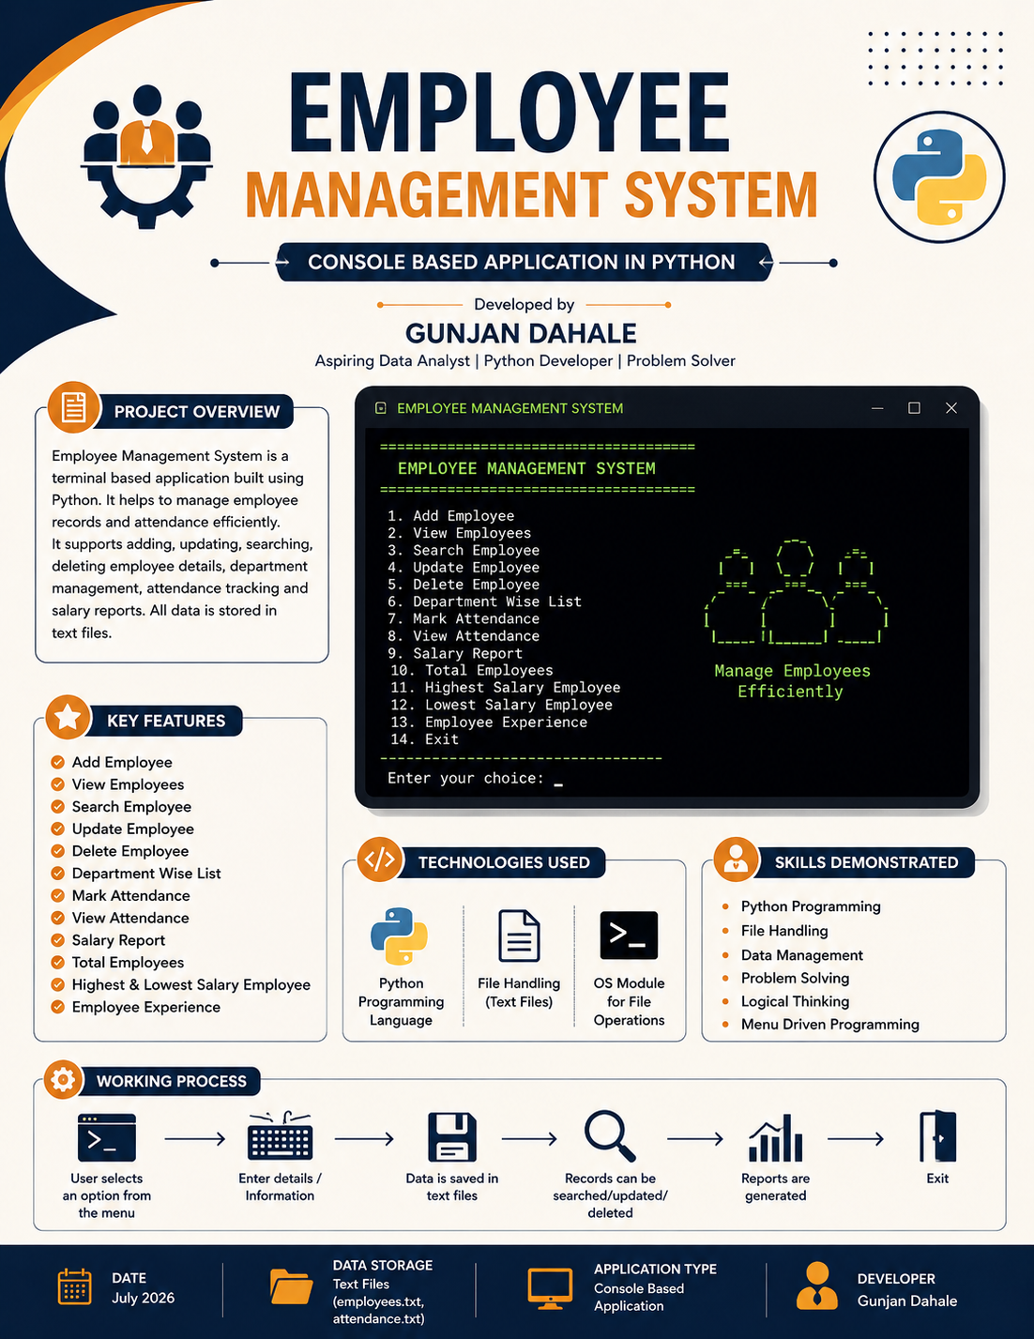

No. | Title | Short Statement
1. | Title | Overview of Employee Management System.
2. | Introduction | Console-based application developed in Python.
3. | Modules Used | OS module and file handling concepts.
4. | Employee Information | Employee ID, name, age, salary, email, etc.
5. | Department Management | Department-wise employee list management.
6. | Attendance | Mark and manage attendance records.
7. | Employee Operations | Add, search, update, and delete employees.
8. | Reports | Salary reports and employee statistics.
9. | Data Storage | Store records in text files.
10. | Conclusion | Project outcomes and future scope.

Technologies Used :-
Technology | Purpose
Python | Programming language
File Handling | Store employee data
Text Files | Database
OS Module | File operations

Features :- Employee Details Stored :-
- Add Employee Employee ID
- View Employees Name
- Search Employee Age
- Update Employee Gender
- Delete Employee Department
- Department-wise Employee List Designation
- Mark Attendance Salary
- View Attendance Phone Number
- Salary Report

File Structure :- Modules Used :-
├── main.py os
├── employees.txt File handling (open, read, write)
└── attendance.txt

Project Workflow :-

User Selects Option

Main Menu

Start

Show Result

Save Data

Perform Selected Operation

Exit

- Main Menu :-
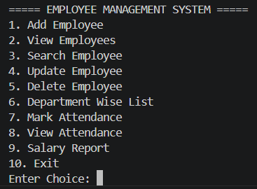

- Add Employee :-
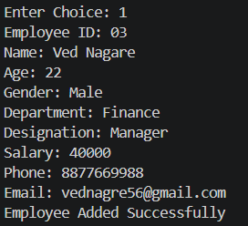

- View Employee :-

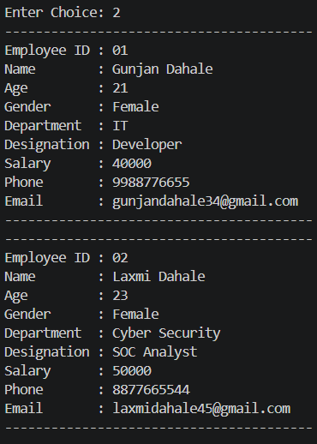

- Search Employee :-
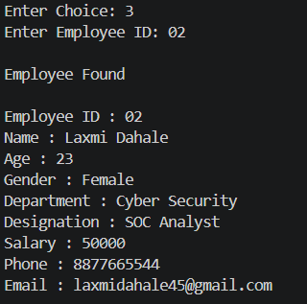

- Department wise List :-
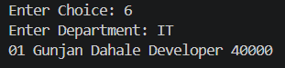

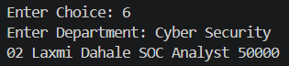

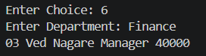

- View Attendance :-
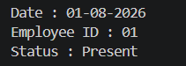

- Salary Report :-
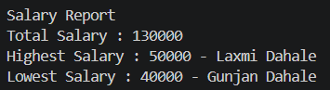

-------------------------------------------------------------------------------------------------------------
Advantages :-
- Easy to use
- Saves time
- Reduces paperwork
- Efficient data management
- Simple interface
Conclusion :-

The Employee Management System is a terminal-based application developed using Python and file handling concepts. It helps in managing employee records, attendance, and salary reports efficiently. The project provides features such as adding, searching, updating, and deleting employee information. It demonstrates the use of programming concepts like functions, loops, conditions, and file operations. This system reduces manual work and improves data management accuracy. Overall, the project enhanced my problem-solving and Python programming skills.

